A Partnership beyond country borders

Sophies Minde Ortopedi AS (SMO) is a Orthopaedic clinic in Oslo Norway. It is a private company owned by Oslo University Hospital.
www.sophiesminde.no
Cambodian School of Prosthetics and Orthotics (CSPO) is located in Phnom Penh, Cambodia. The school is run by the Cambodia Trust, a UK registered charity as the only school of Prosthetics and Orthotics in the world with ISO 9001:20008 certification.
www.cspo.org.kh
Tanzanian Training Centre for Orthopaedic Technologists (TATCOT) is located in Moshi, Tanzania. TATCOT is a supra-regional training centre providing courses in the field of orthopaedic technology in Africa and enrolls students from all English speaking African countries as well as Asian continent and other interested countires.
www.tatcot.org
Kamuzu Central Hospital (KCH) is a Governmental Hospital in Lilongwe, Malawi. In relation with an ongoing development of the orthopaedic surgical department of the hospital, a new Prosthetic and Orthotic Centre has been built and opened in 2009.
www.malawi.gov.mw

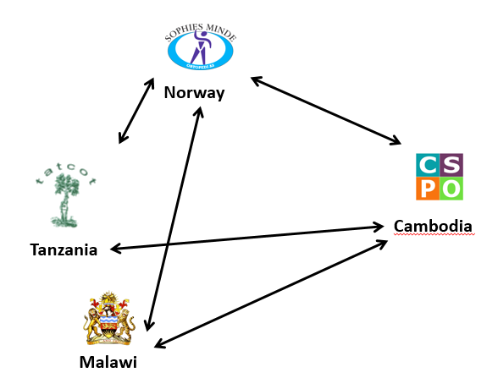

In 2009 a partnership between four institutions in four different countries – Malawi, Tanzania, Cambodia and Norway – was initiated by Rune Nilsen, Head of Department at Sophies Minde Ortopedi AS in Oslo, Norway. Together they are creating opportunities and building capacity within the field of physical rehabilitation in Africa, Asia and Norway, first of all for people with disabilities but also for health care professionals.
The end of the five year plan they made in 2009 is moving closer and the results of the collaboration is starting to show. Through sharing of knowledge, experiences and personnel the four institutions are successfully moving closer to their common vision that goes beyond country boarders and cultural differences: god quality of life for people with physical disabilities. One of the biggest achievements so far is the collaboration between the two schools in Africa and Asia.
The partnership is based on mutual exchange of personnel and is primarily financed through funds from FK Norway (Fredskorpset). FK is a tool for official Norwegian development cooperation, is a governmental body under the Ministry of Foreign Affairs, and is fully financed from the National Budget. FK gives financial support to organizations and companies that wish to exchange staff with another organization; “We are convinced that the world becomes a little more just when people get to know each other better and create values together” (Source: http://www.fredskorpset.no/en/about-us/).
FK Norway gives both opportunities and limitations to the partnership. The FK-model doesn’t always provide the best framework to a physical rehabilitation project within the P&O field, but at the time being it is the best option, and we are very grateful FK Norway exists, says Rune Nilsen. The objectives cannot be reached through the exchange of personnel only. The partnership also depends on collaboration with several other organizations and NGO’s, schools, universities and research institutions. The partnership has turned in

to a global network with the endless possibilities that it represents.
KCH (Malawi), CSPO (Cambodia), TATCOT (Tanzania) and SMO (Norway) exchanges personnel for 11 months or longer. The four institutions have a partner meeting every year, were they plan the next round of exchange and evaluate the ongoing exchange. Through the partner meetings the four partner institutions have successfully managed to create a common platform and understanding of each other’s role in the project - and how to get the most out of the project and each other. Each organization has objectives for their own institution, and each participant has objectives and activities for each exchange that will help build the professional capacity of the participant and the partner organization. The institutions objectives are reached through activities performed by the participant, through seminars and use of telemedicine.
Project name:
Capacity Building in Prosthetics and Orthotics Educational Centres and Services in Low Income Countries.
Content:
Prosthetic and orthotic educational capacity building in Asia, Africa and Norway. Enhancing better quality of education and clinical services in physical rehabilitation in Asia, Africa and Norway.
Exchange available resources between equal partners in three continents in education and comprehensive physical rehabilitation services.
Number of participants since 2004, from:
Norway: 11
Cambodia: 13
Tanzania: 10
Australia: 1
UK: 1
Malawi: 8
Number of exchanges since 2004:
50 exchanges

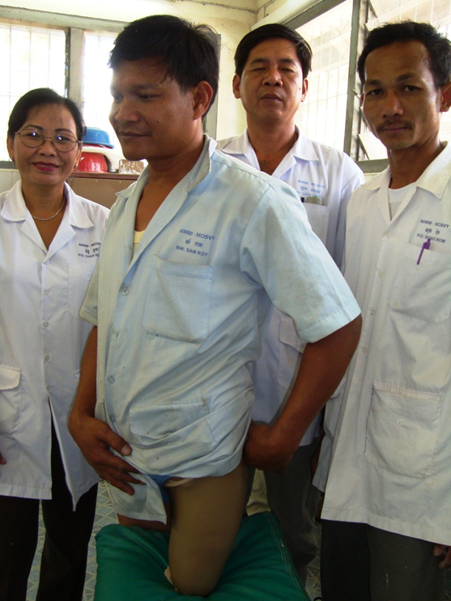

At the partner meeting the partners presents the areas that they need to strengthen in their own institution. Based on those needs the professional criteria’s for the participants are being set, and seminars are being planned. Practical clinical seminars within the P&O field are being held on request by the receiving partner on topics that needs special focus. So far 42 different seminars have been conducted. The topics have for example been upper limb prosthetics, spinal orthotics, MAS-socket design, congenital lower limb prosthetics, orthotic treatment in cerebral palsy among others.
We can in some ways compare the partnership with the ISO (International Organization for Standardization) which is the world’s largest developer of International Standards. The partners seek to identify successful “standards” within the partnership that can be adopted, often with some adjustments, by one or several of the other partners. The name ISO is derived from the Greek isos, meaning equal, which also is one of the corner stone’s in the partnership; the four institutions are all equal partners.

Do you have questions in regards to the project you can find the contact information below.

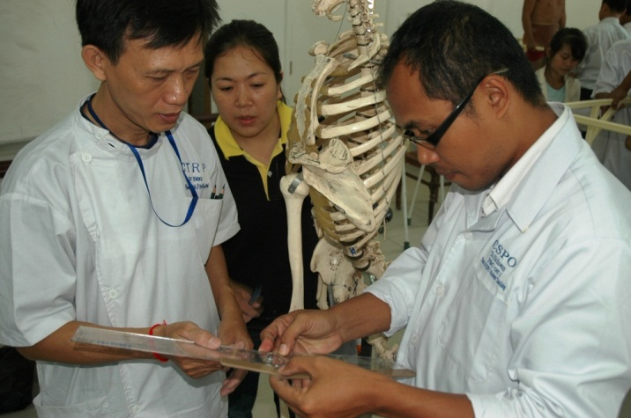

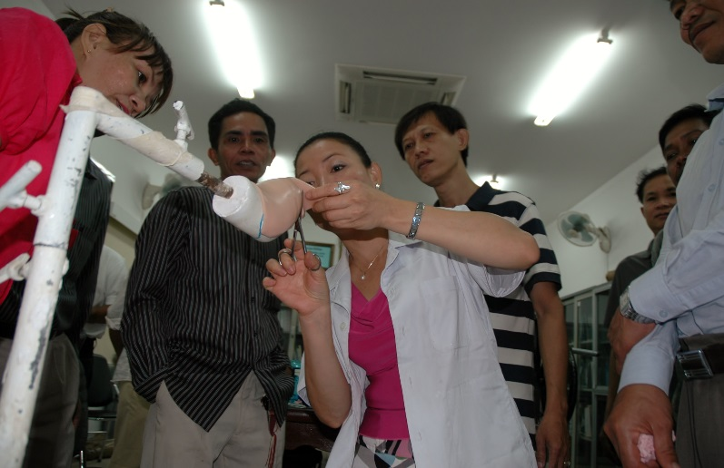
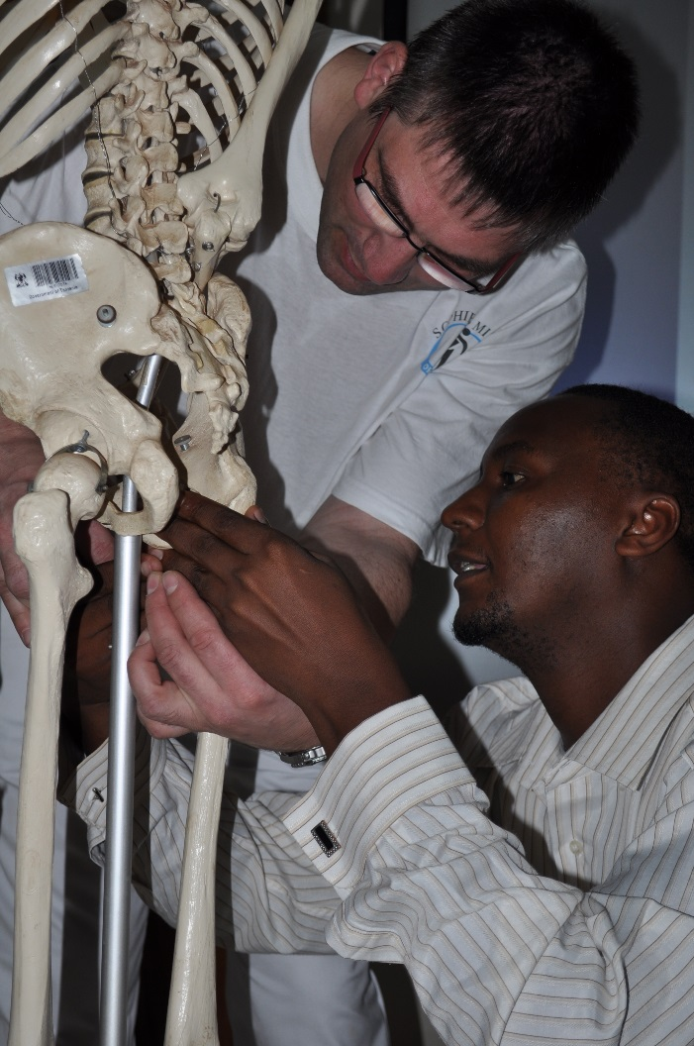

Sophies Minde Ortopedi AS, Oslo, Norway (Coordinating partner).
Rune Nilsen
Mobile: +47 99 27 20 67
e-mail: rune.nilsen@sophiesminde.no

CSPO, Phnom Penh, Cambodia
Sisary Kheng
Mobile: +855 12 49 23 61
E-mail: ksisary@cambodiatrust.org.kh
TATCOT, Moshi, Tanzania
Longini Mtalo
Mobile: +255272753986
E-mail: longinimtalo@yahoo.com
KCH, Lilongwe, Malawi
Awonenji Sifo Nyasulu
Mobile: +265999574577
E-mail: sifonyasulu@yahoo.com

